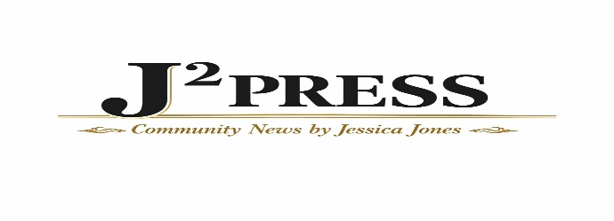

Advertising Rate Sheet

Top Banner Ad
5 vertical inches – $25.00 per day
Additional inches: $3.00 per inch per day

Marquee Moving Ad / 1-Inch Static Top Ad: $10.00 per day

Sidebar
Left or Right Sidebar (6 vertical inches):
· $10.00 per day
· $125.00 per month
· $500.00 per year
Sponsorship: 2 vertical inches= $225.00 per year, $25.00 per additional inch

News Column
$20.00 per placement (up to 10 vertical inches) with link
Additional inches over 10: $2.00 per inch
If combining with sidebar: $10.00 per placement (EX: $10.00 + $10.00= $20.00 per placement)
includes 1 Social post and a 3-day sidebar spot
~ Daily rate per placement thereafter ~
~ Ads scroll off the page depending on number of daily posts ~

Personal & Community Ads
Personal announcements: $5.00 per day
Obituaries: $125.00 per month, which includes one placement per individual, unlimited individuals, and a 3-inch promotional space with your logo and website link.

Special Advertising Packages
Auctions- $125.00 per event. Includes 1 daily J² Press placement with link and 1 Social post
School Districts- $10.00 (up to 10 vertical inches) per placement ~ Social post with link included per placement
Benefits- Free Social post, 1 free J² Press insertion, and added to Community Calendar
Non-Profit Events/ Fundraisers- Quote
Combination Packages – Quote

Ad Design
One-time design fee: $25.00 per advertisement

Social
Facebook News Feed- $10.00 per post

Social Package- Initial placement on J² Press with link + 1 Social post
$20.00 Initial, then $5.00 per placement on J² Press only thereafter

Directory
$10.00 per year on the directory page with your website/ social link included

Multiple day and/ or section discounts available

*Advertising rates will be reviewed on an annual basis and are subject to change upon no less than thirty (30) days’ prior written notice.

